https://www.slideshare.net/bernardsenam/system-calls-30543466
https://www2.latech.edu/~box/csc222/lecture05.pdf

What is a System Call?
A system call is a method for a computer program to request a service from the kernel of the operating system on which it is running. A system call is a method of interacting with the operating system via programs. A system call is a request from computer software to an operating system's kernel.
System calls are usually made when a process in user mode requires access to a resource. Then it requests the kernel to provide the resource via a system call.
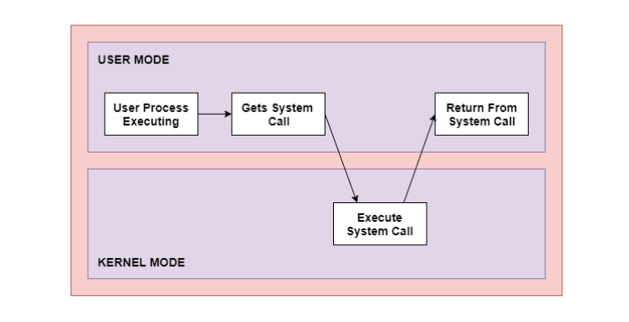
As can be seen from this diagram, the processes execute normally in the user mode until a system call interrupts this. Then the system call is executed on a priority basis in the kernel mode. After the execution of the system call, the control returns to the user mode and execution of user processes can be resumed.

Why do you need system calls in Operating System?
There are various situations where you must require system calls in the operating system. Following of the situations are as follows:
- It is must require when a file system wants to create or delete a file.
- Network connections require the system calls to sending and receiving data packets.
- If you want to read or write a file, you need to system calls.
- If you want to access hardware devices, including a printer, scanner, you need a system call.
- System calls are used to create and manage new processes.

How System Calls Work
The Applications run in an area of memory known as user space. A system call connects to the operating system's kernel, which executes in kernel space. When an application creates a system call, it must first obtain permission from the kernel. It achieves this using an interrupt request, which pauses the current process and transfers control to the kernel.
If the request is permitted, the kernel performs the requested action, like creating or deleting a file. As input, the application receives the kernel's output. The application resumes the procedure after the input is received. When the operation is finished, the kernel returns the results to the application and then moves data from kernel space to user space in memory.
A simple system call may take few nanoseconds to provide the result, like retrieving the system date and time. A more complicated system call, such as connecting to a network device, may take a few seconds. Most operating systems launch a distinct kernel thread for each system call to avoid bottlenecks. Modern operating systems are multi-threaded, which means they can handle various system calls at the same time.

Types of System Calls
There are mainly five types of system calls. These are explained in detail as follows −

Process Control
These system calls deal with processes such as process creation, process termination etc.

File Management
These system calls are responsible for file manipulation such as creating a file, reading a file, writing into a file etc.

Device Management
These system calls are responsible for device manipulation such as reading from device buffers, writing into device buffers etc.

Information Maintenance
These system calls handle information and its transfer between the operating system and the user program.

Communication
These system calls are useful for inter-process communication. They also deal with creating and deleting a communication connection.

open()
The open() system call allows you to access a file on a file system. It allocates resources to the file and provides a handle that the process may refer to. Many processes can open a file at once or by a single process only. It's all based on the file system and structure.

read()
It is used to obtain data from a file on the file system. It accepts three arguments in general:
- A file descriptor.
- A buffer to store read data.
- The number of bytes to read from the file.
The file descriptor of the file to be read could be used to identify it and open it using open() before reading.

wait()
In some systems, a process may have to wait for another process to complete its execution before proceeding. When a parent process makes a child process, the parent process execution is suspended until the child process is finished. The wait() system call is used to suspend the parent process. Once the child process has completed its execution, control is returned to the parent process.

write()
It is used to write data from a user buffer to a device like a file. This system call is one way for a program to generate data. It takes three arguments in general:
- A file descriptor.
- A pointer to the buffer in which data is saved.
- The number of bytes to be written from the buffer.

fork()
Processes generate clones of themselves using the fork() system call. It is one of the most common ways to create processes in operating systems. When a parent process spawns a child process, execution of the parent process is interrupted until the child process completes. Once the child process has completed its execution, control is returned to the parent process.

close()
It is used to end file system access. When this system call is invoked, it signifies that the program no longer requires the file, and the buffers are flushed, the file information is altered, and the file resources are de-allocated as a result.

exec()
When an executable file replaces an earlier executable file in an already executing process, this system function is invoked. As a new process is not built, the old process identification stays, but the new process replaces data, stack, data, head, etc.

exit()
The exit() is a system call that is used to end program execution. This call indicates that the thread execution is complete, which is especially useful in multi-threaded environments. The operating system reclaims resources spent by the process following the use of the exit() system function.

